**HTML methods using POSTMAN**

POST : This API Will add new place into Server

**URL**  [**https://rahulshettyacademy.com**](https://rahulshettyacademy.com/)**/maps/api/place/add/json?key=** **qaclick123**

**Sample Body :**

{

"location": {

"lat": -38.383494,

"lng": 33.427362

},

"accuracy": 50,

"name": "Frontline house",

"phone_number": "(+91) 983 893 3937",

"address": "29, side layout, cohen 09",

"types": [

"shoe park",

"shop"

],

"website": "http://google.com",

"language": "French-IN"

}

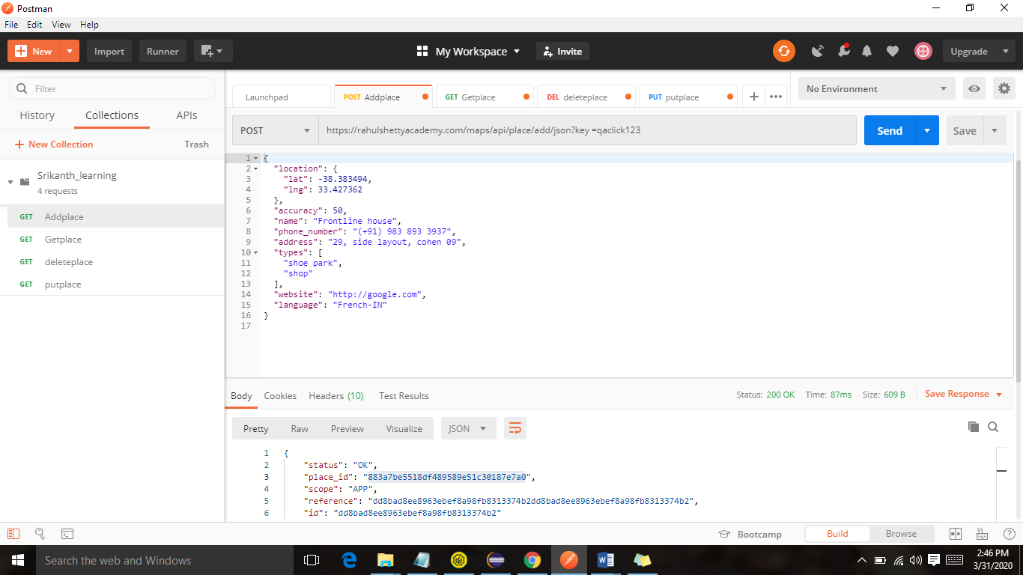

**Posted successfully Response status 200**

{

    "status": "OK",

    "place_id": "883a7be5518df489589e51c30187e7a0",

    "scope": "APP",

    "reference": "dd8bad8ee8963ebef8a98fb8313374b2dd8bad8ee8963ebef8a98fb8313374b2",

    "id": "dd8bad8ee8963ebef8a98fb8313374b2"

}

**GET REQUEST**

**url :** **http://rahulshettyacademy.com/maps/api/place/get/json?place_id=883a7be5518df489589e51c30187e7a0&key=qaclick123**

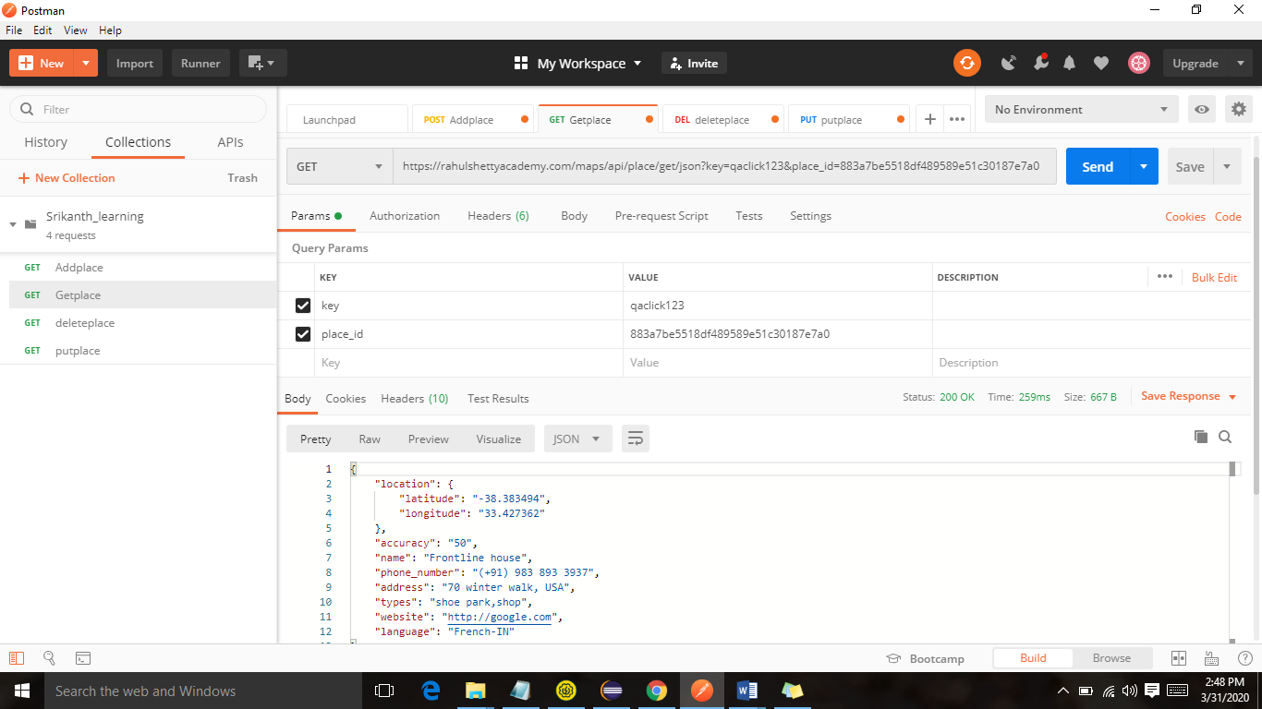

Response

{

    "location": {

        "latitude": "-38.383494",

        "longitude": "33.427362"

    },

    "accuracy": "50",

    "name": "Frontline house",

    "phone_number": "(+91) 983 893 3937",

    "address": "70 winter walk, USA",

    "types": "shoe park,shop",

    "website": "http://google.com",

    "language": "French-IN}

**Deleting the response which I have posted before**

<https://rahulshettyacademy.com/maps/api/place/delete/json?key=qaclick123>

body By using id

{

"place_id":"09831c0a10a08173cbcca91a3f1286af"

}

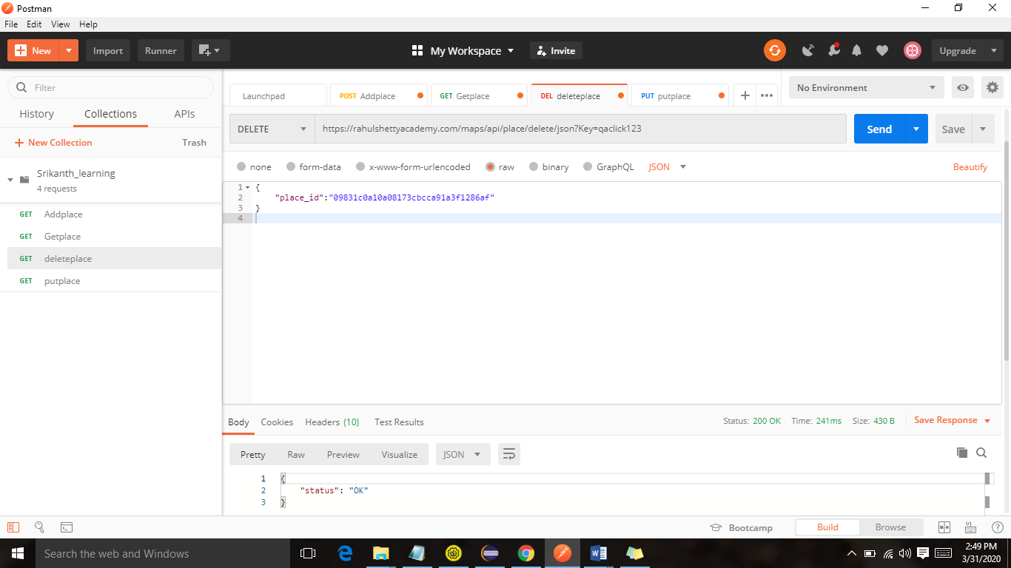

Response

{

    "status": "OK"

}

**Updating some address by using PUT**

Before put response is as below

url: http://rahulshettyacademy.com/maps/api/place/get/json?place_id= 883a7be5518df489589e51c30187e7a0 &key=qaclick123

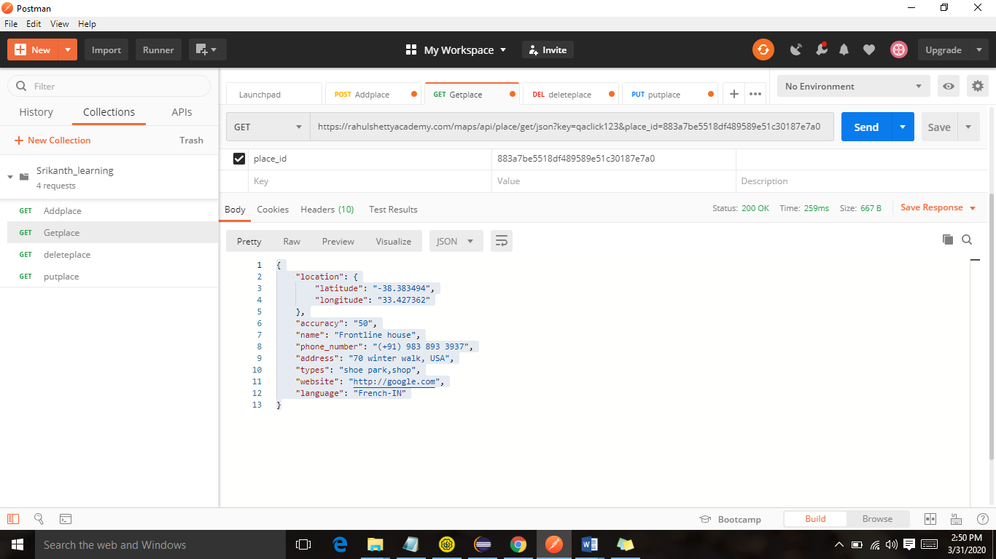

After put request address got updated

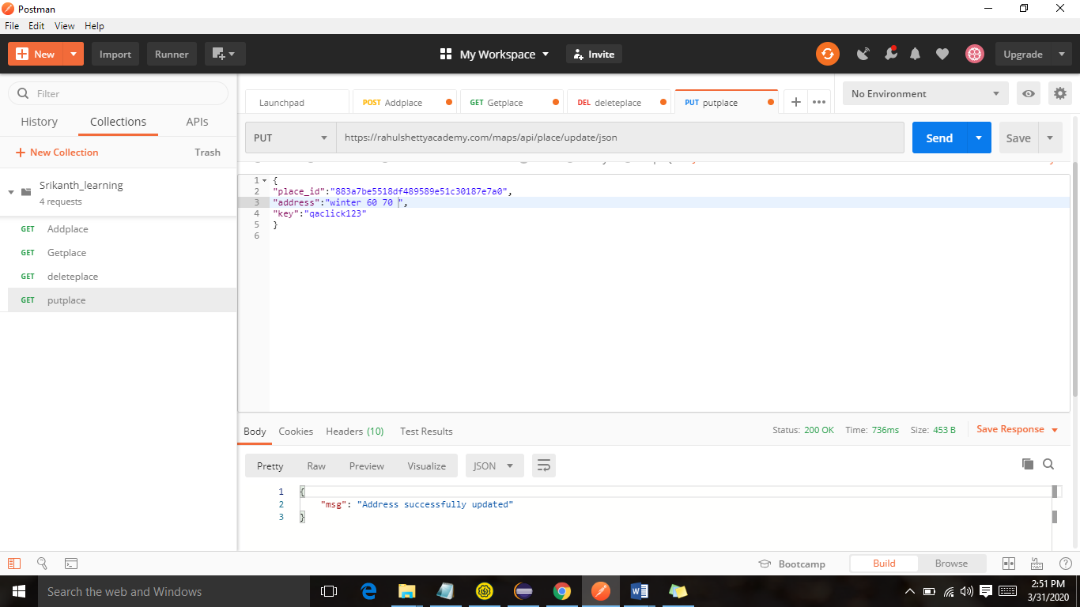

Response

{

    "msg": "Address successfully updated"

}

Checking in get response whether it got updated successfully

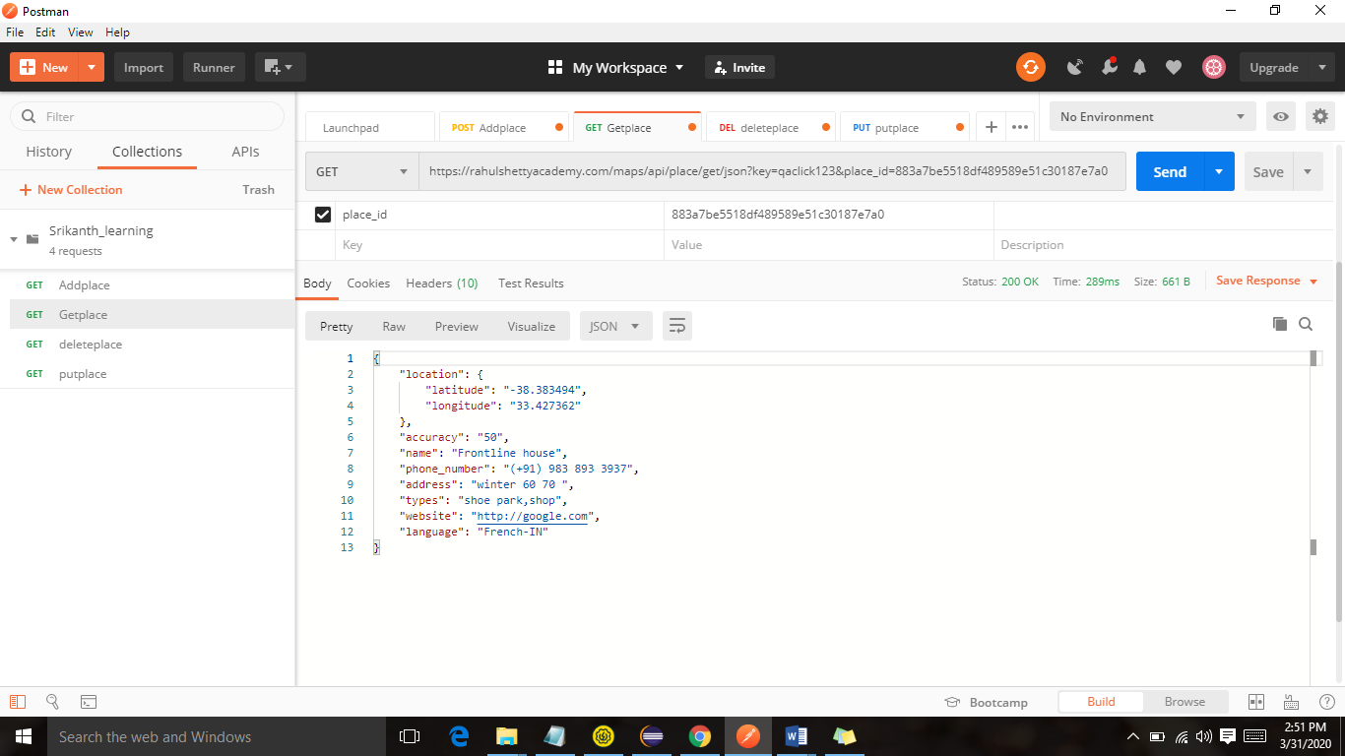

Response

{

    "location": {

        "latitude": "-38.383494",

        "longitude": "33.427362"

    },

    "accuracy": "50",

    "name": "Frontline house",

    "phone_number": "(+91) 983 893 3937",

    "address": "winter 60 70 ",

    "types": "shoe park,shop",

    "website": "http://google.com",

    "language": "French-IN"

}